Internet Protocol Lab Assignment-9
NAME-Kushagra Ojha
ENROLLMENT NUMBER –CB.SC.P2CYS25029

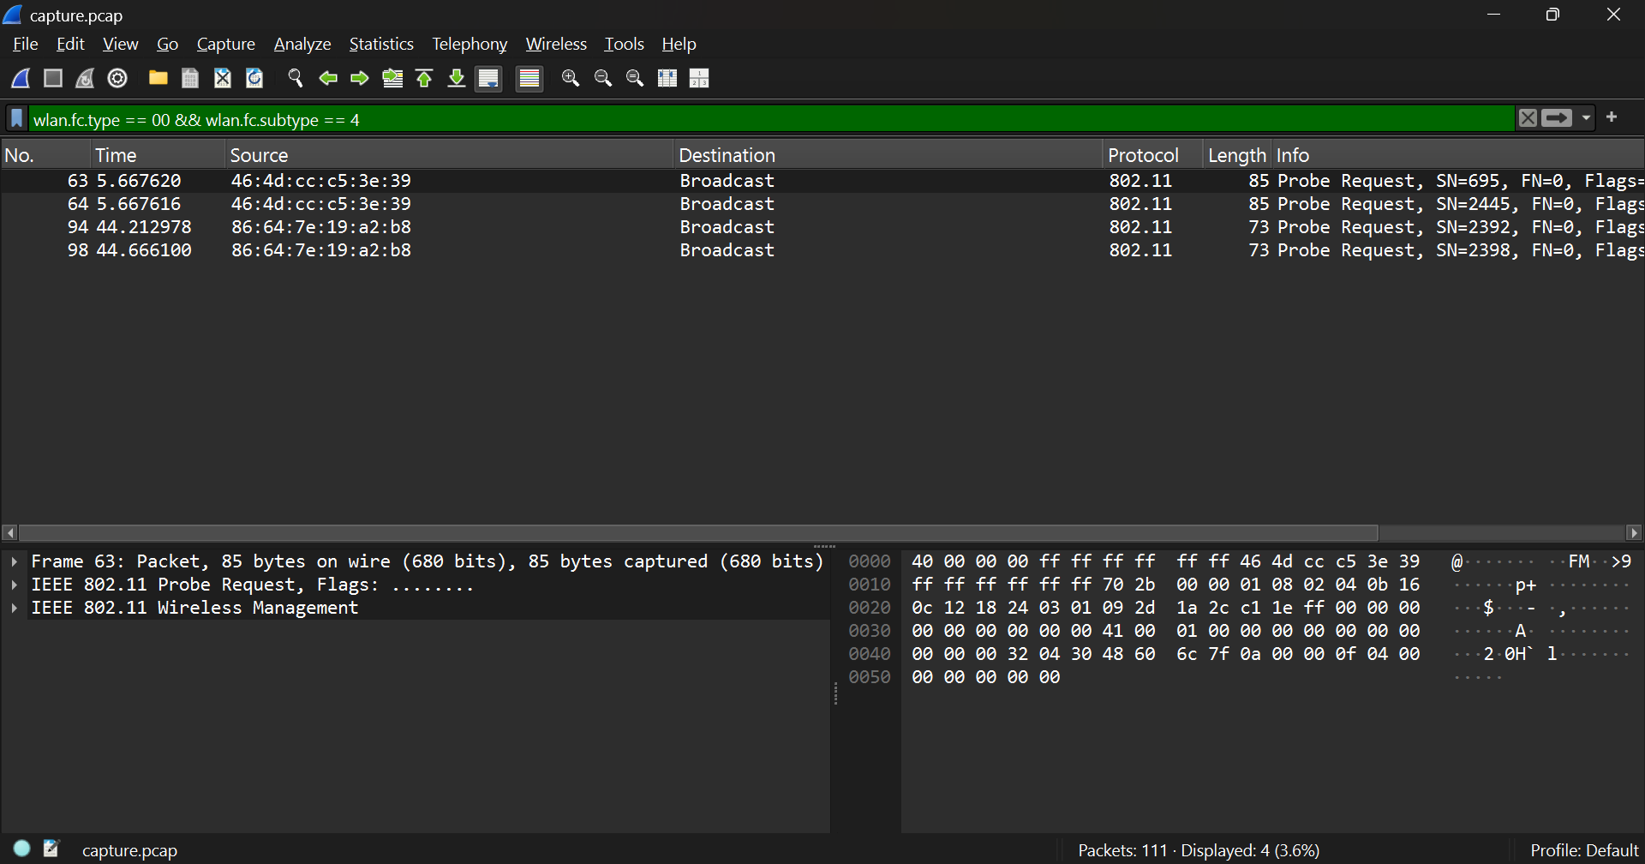
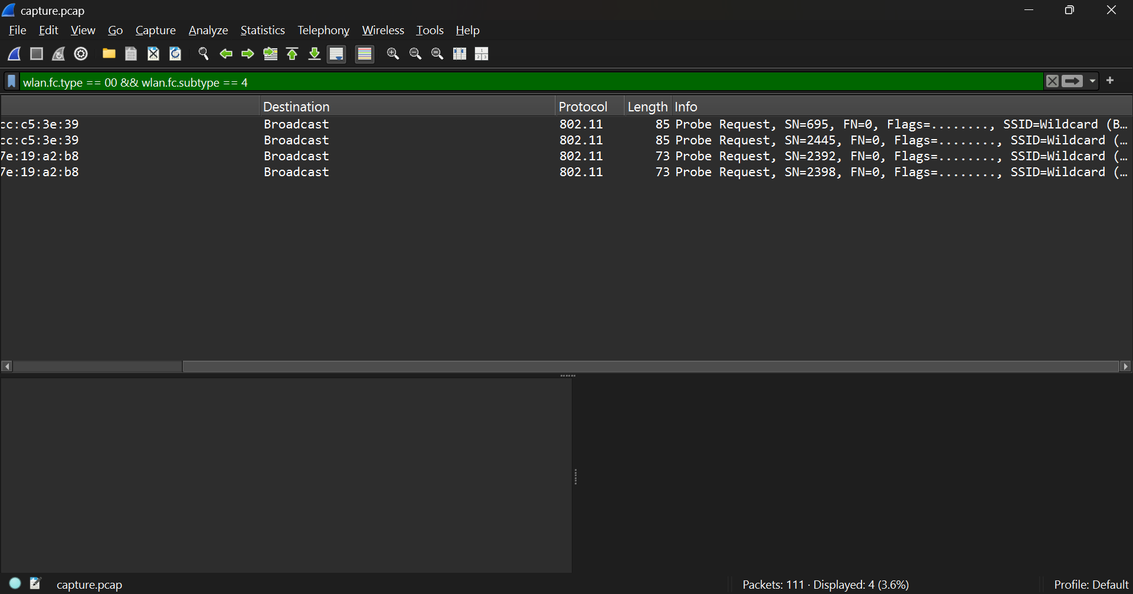
Probe Request frames are sent by a client device to actively search for available Wi-Fi networks.
These frames reveal information about the client such as:
- The SSID (network name) the client is trying to find — in this capture it shows SSID: Wildcard (Broadcast), meaning the client is looking for any available network.
- The client’s supported data rates and 802.11 capabilities (like 802.11n support, channel preferences, and security types).
- The source MAC address of the client, which uniquely identifies its wireless interface.
The device sends probe requests before connecting to discover nearby access points more quickly than waiting for beacon frames, to check which APs are within range, and to select the one that best matches its supported rates and security settings for connection.

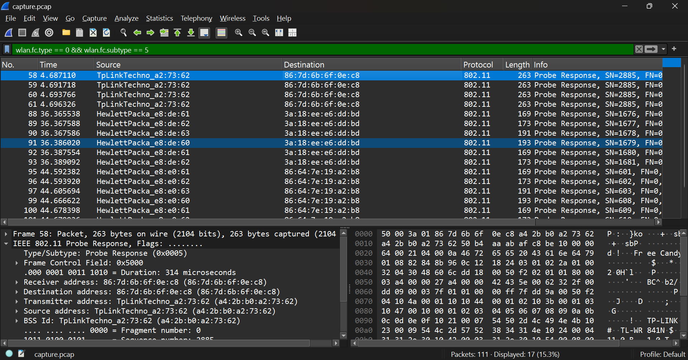
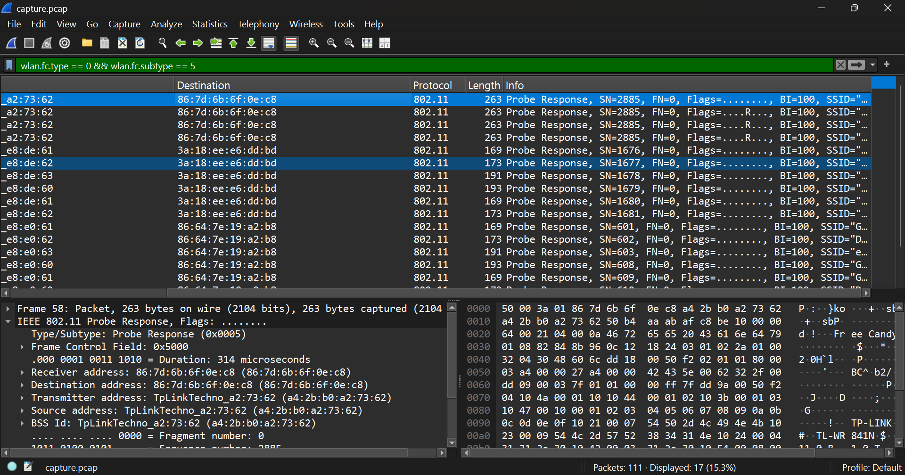
When the filter wlan.fc.type == 0 && wlan.fc.subtype == 5 is applied, the capture displays several Probe Response frames.
From the screenshot, the responding Access Points (APs) include:
- TpLinkTechno_a2:73:62
- HewlettPacka_e8:6d:bd
These access points are replying to clients that had earlier sent broadcast (wildcard) probe requests.
Details shared by the APs in their Probe Response frames include:
- SSID: The network name being advertised (e.g., BT-100, TP-LINK_841N_5G, etc.)
- Channel/Frequency: Indicates which radio channel (e.g., Channel 6 or Channel 11) the AP is operating on.
- Supported Data Rates: Lists transmission speeds and 802.11 standards (b/g/n/ac) supported.
- Capabilities Information: Includes security settings (e.g., WPA2, RSN), QoS support, and short preamble options.
- BSSID: The unique MAC address identifying the access point.
Explanation:
Probe Responses allow clients to learn detailed network parameters from nearby APs. Using this information—SSID, signal strength, and supported features—the client decides which access point offers the best compatibility and signal for association.

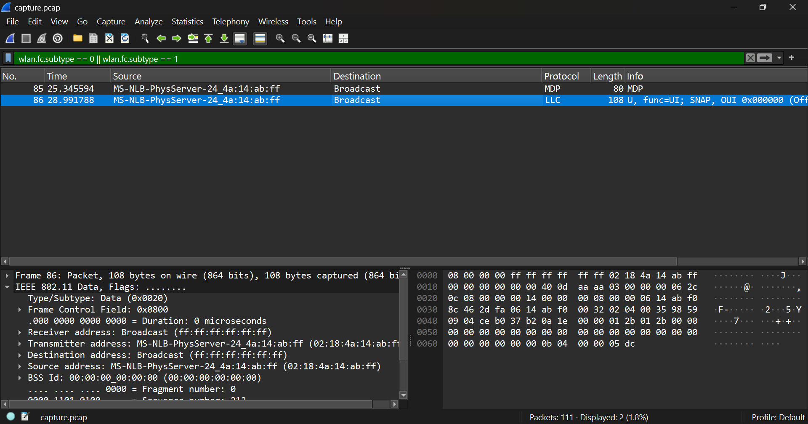
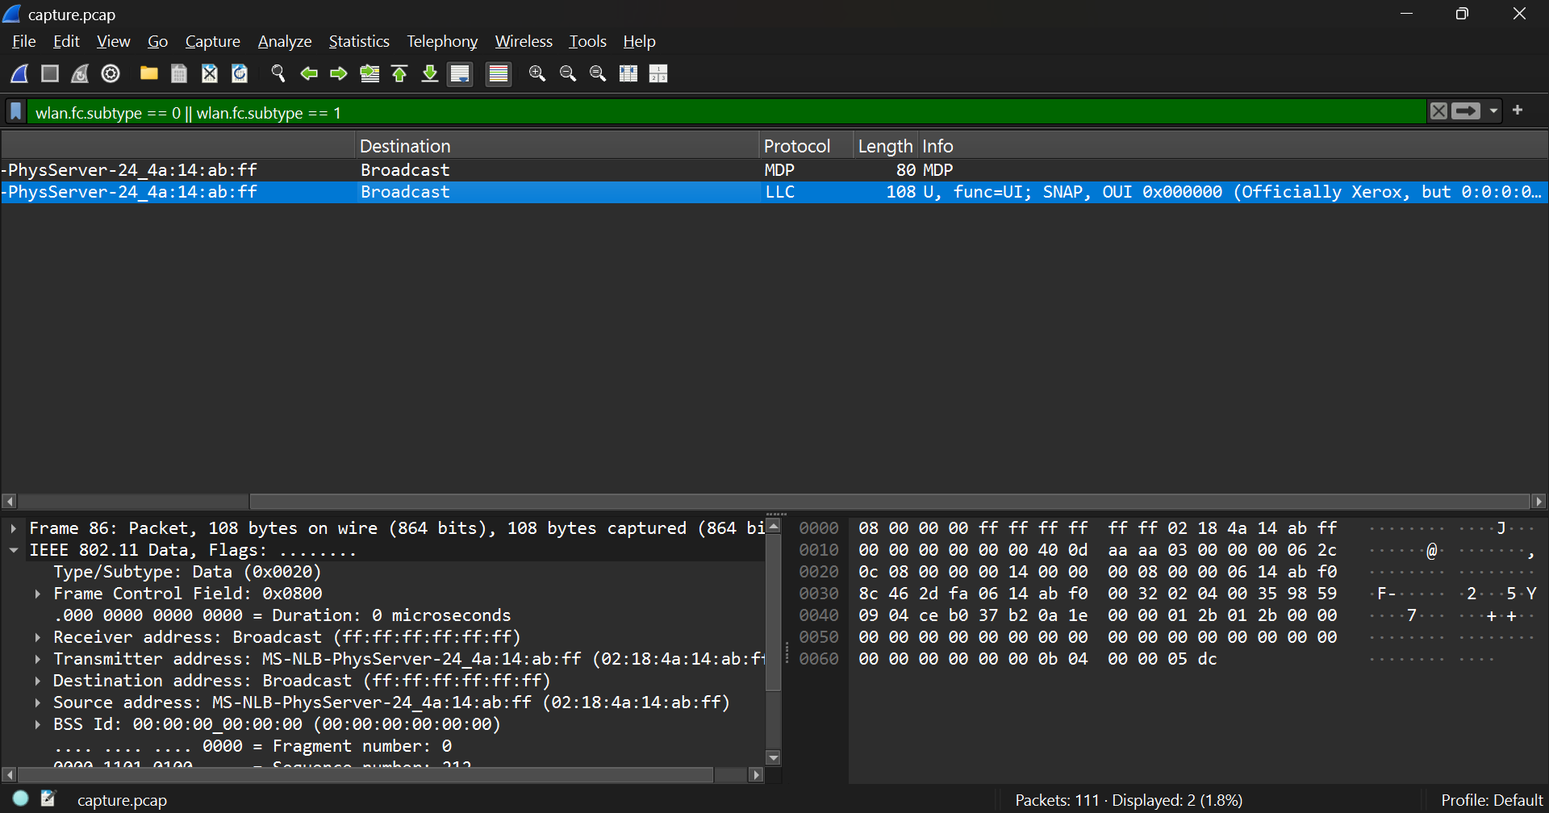
When the filter wlan.fc.subtype == 0 || wlan.fc.subtype == 1 is applied, the capture shows Association Request and Association Response frames exchanged between the client and the access point (AP).
Parameters exchanged during association:
- SSID: The network name the client wants to join.
- Supported data rates: Transmission speeds that the client can handle.
- Capabilities information: Such as QoS support, short preamble, and security features (e.g., WPA2/WPA3).
- Listen Interval: How often the client wakes up to listen for buffered traffic from the AP.
- Association ID (AID): Assigned by the AP in its response to identify the client in the network.
Explanation:
- The Association Request is sent by the client after successful authentication to formally request connection to the AP.
- The Association Response from the AP includes an AID and confirmation that the client is now associated.
- These exchanges complete the link-layer connection setup, allowing the client to start data communication over the network.

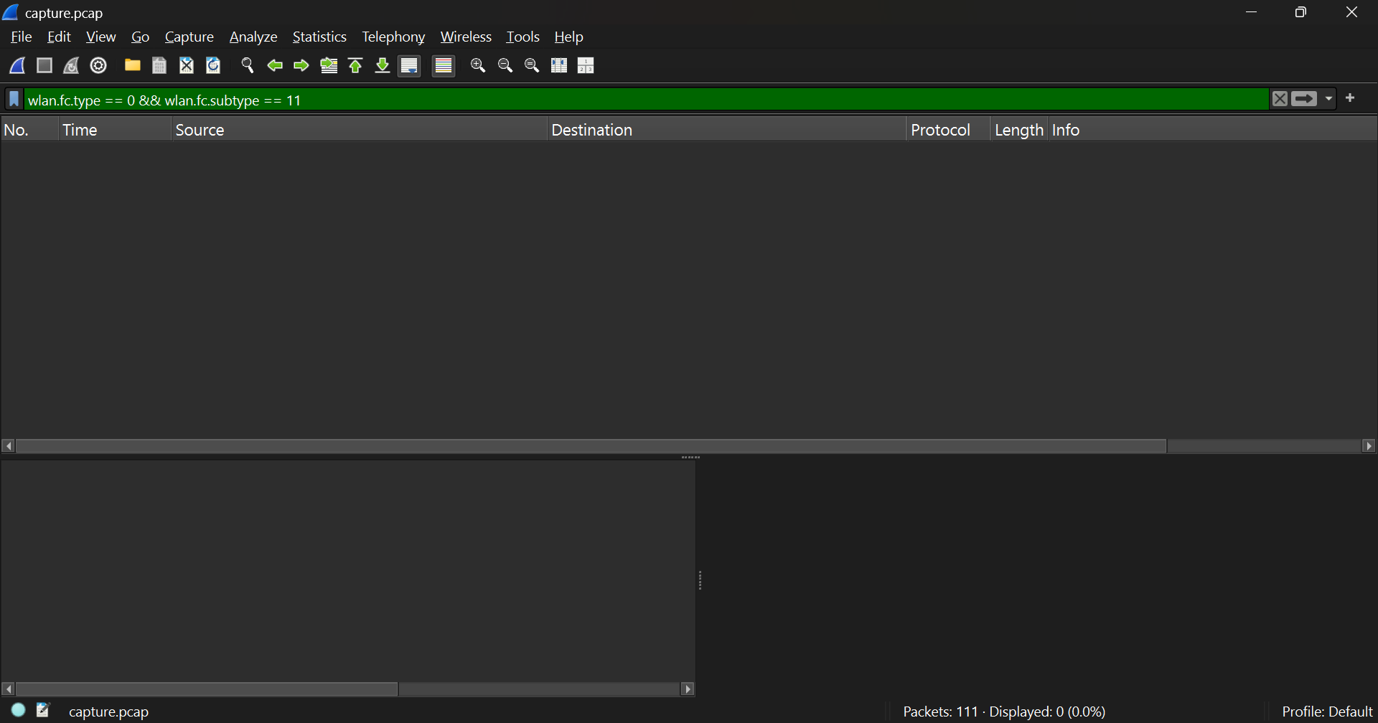

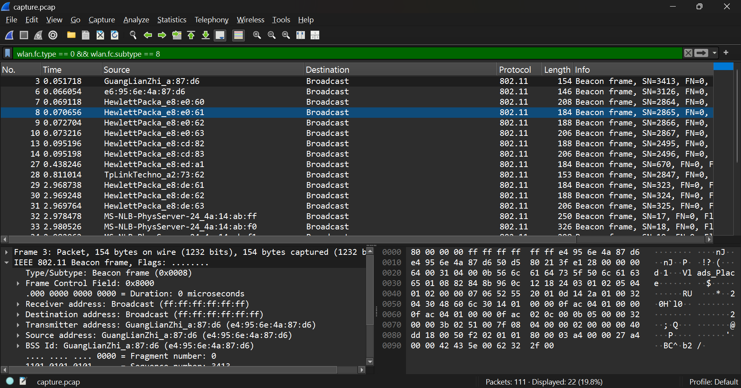
When the filter wlan.fc.type == 0 && wlan.fc.subtype == 8 is applied, the capture displays multiple Beacon frames transmitted by different access points (APs) such as GuangLianZhi_a:87:d6, HewlettPacka_e8:0e:60, and TpLinkTechno_a2:73:62.
SSIDs being advertised:
From the captured beacon frames, the SSIDs include names like:
- ads_place
- BI-100
- TP-LINK_841N
(Each AP broadcasts its SSID to identify its wireless network.)
How often beacons are sent:
- Beacons are transmitted periodically, typically every 100 milliseconds (0.1 seconds), to announce the presence of a wireless network and maintain synchronization with connected clients.
Network information broadcast through beacon frames:
Each beacon frame carries essential details about the AP and its network, including:
- SSID (network name)
- BSSID (MAC address of the AP)
- Supported data rates and capabilities
- Channel number and frequency band
- Timestamp and beacon interval
- Security information (e.g., WPA2/WPA3 RSN details)
Explanation:
Beacon frames allow nearby client devices to discover available wireless networks and obtain configuration parameters required to initiate a connection. They act as periodic advertisements that define the AP’s identity and operating characteristics.

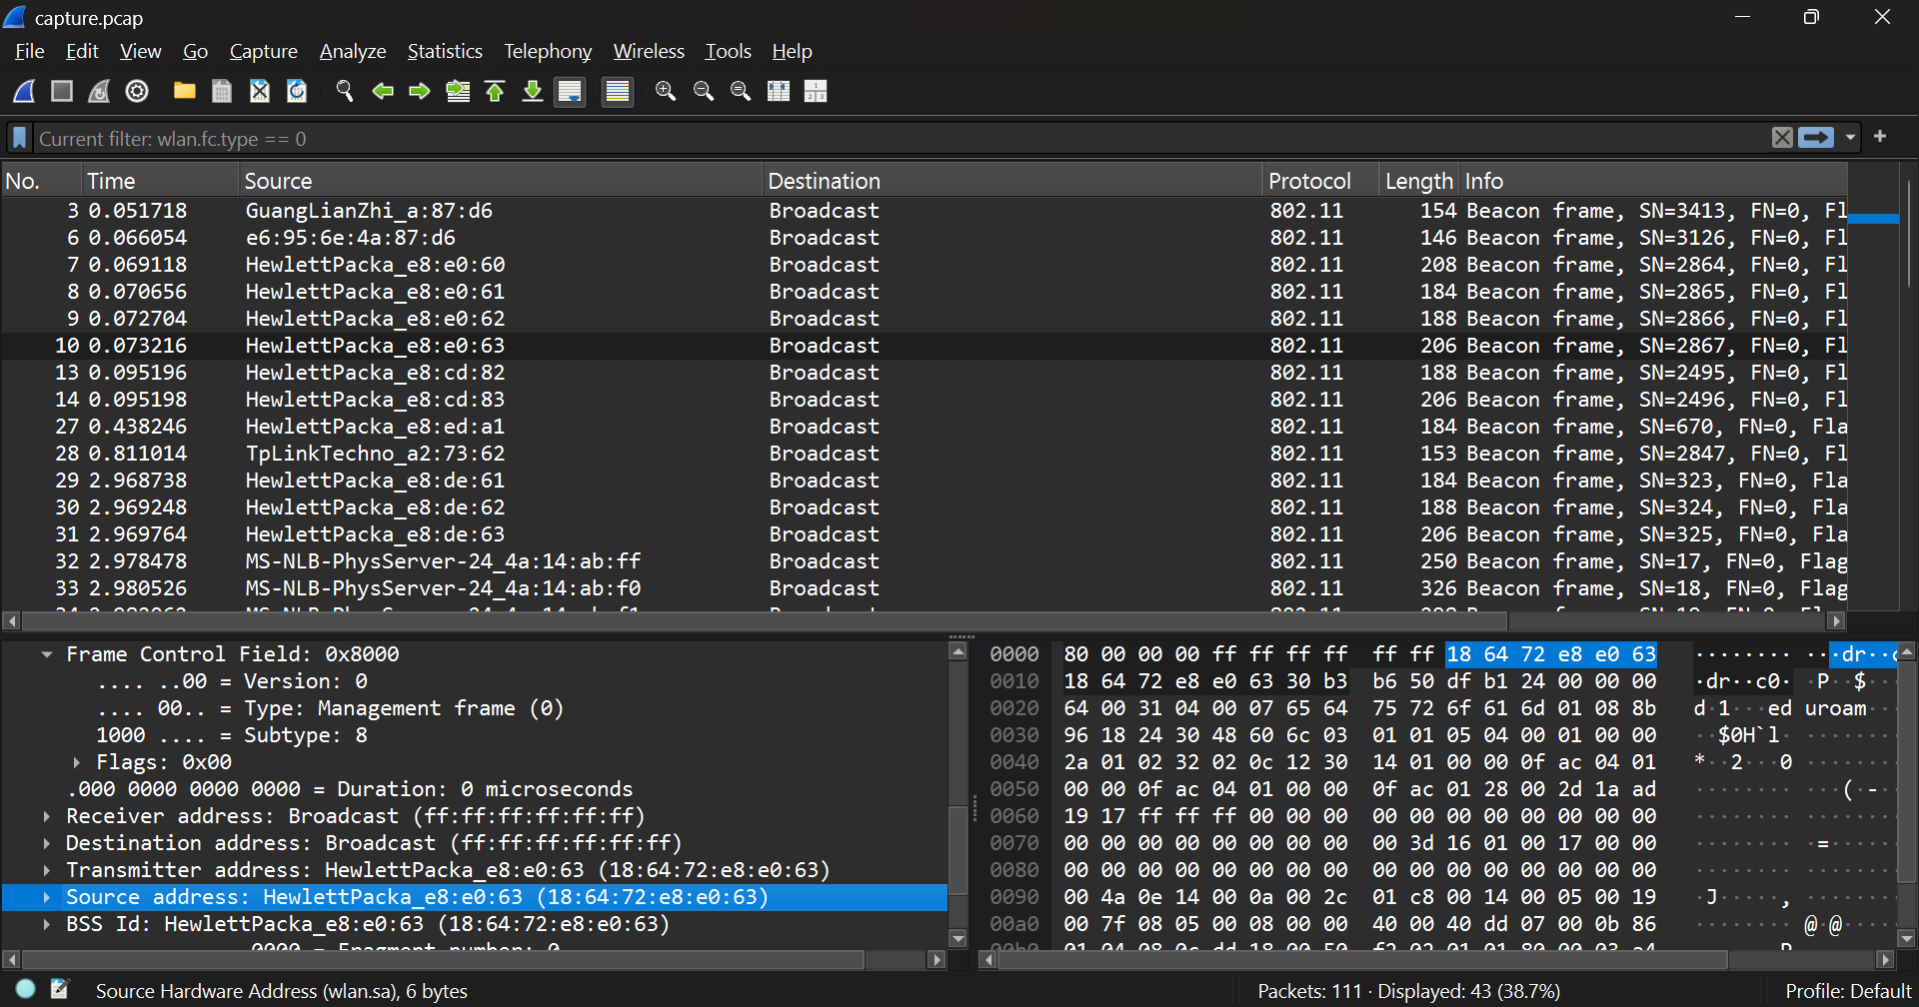
SA (Source Address): the device that transmitted the frame (actual sender).
DA (Destination Address): the intended receiver of the frame (single station or broadcast).
BSSID: the identifier (MAC) of the Basic Service Set (usually the AP’s MAC in infrastructure mode).

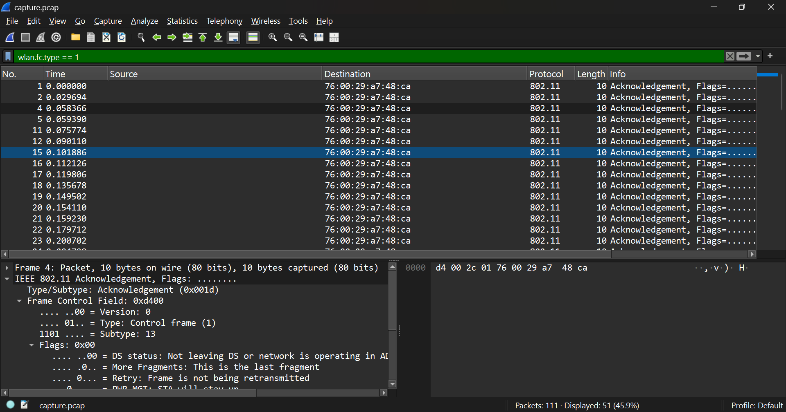
When the filter wlan.fc.type == 1 is applied, the capture displays several control frames, specifically Acknowledgement (ACK) frames between wireless devices.
Purpose and function of control frames:
Control frames are used in IEEE 802.11 networks to manage and coordinate access to the shared wireless medium, helping to prevent collisions and ensure reliable delivery. The key types are:
- RTS (Request to Send): Sent by a station to reserve the channel before sending data.
- CTS (Clear to Send): Sent by the receiver in response to RTS, indicating the channel is clear.
- ACK (Acknowledgment): Sent by the receiver to confirm that a frame was successfully received.
How they prevent collisions:
- RTS/CTS helps avoid the hidden node problem by ensuring that all nearby stations are aware that the channel is reserved for transmission.
- ACK ensures reliable communication; if an ACK is not received, the sender retransmits the frame, reducing packet loss.
From the capture:
- Multiple ACK frames (Subtype 13) are seen, such as between source d4:00:2c:01:76:00 and destination 76:00:29:a7:48:ca.
- Each ACK frame is only 10 bytes long, confirming receipt of a previous data frame.
Conclusion:
The ACK frames in the capture confirm successful frame delivery between wireless devices. Together with RTS and CTS mechanisms, these control frames maintain efficient and collision-free communication in Wi-Fi networks.

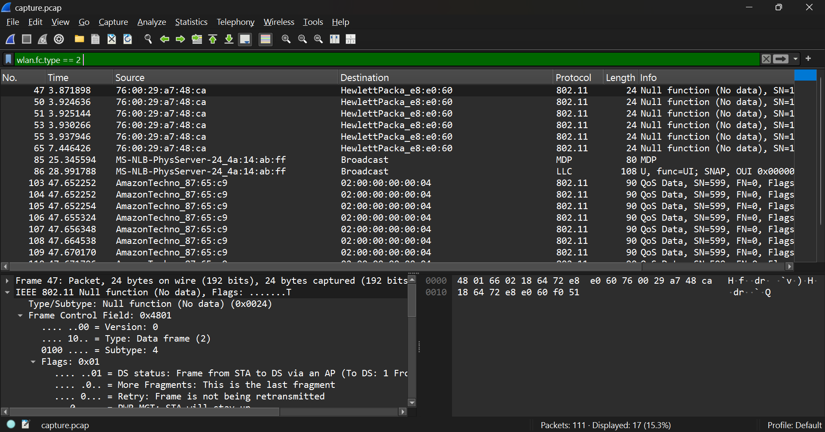
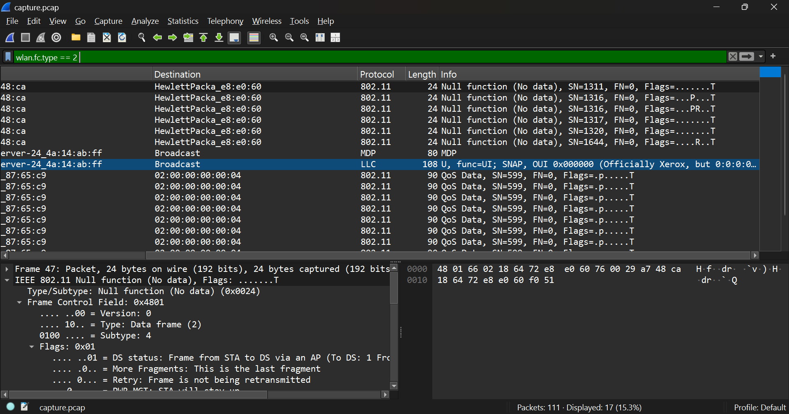
When the filter wlan.fc.type == 2 is applied, the capture shows Data frames, including Null Data and QoS Data frames.
Encapsulation of user data:
- The 802.11 Data frame encapsulates user data (from higher layers like IP, TCP, or UDP) for wireless transmission.
- The data from upper layers is carried within the frame body, similar to how Ethernet carries payloads.
- Inside the payload, you’ll find LLC (Logical Link Control) and SNAP (Subnetwork Access Protocol) headers, followed by the higher-layer data (like IP packets).
Additional headers added at the 802.11 layer:
- MAC Header – contains:
  - Frame Control (type, subtype, flags)
  - Duration/ID
  - Address fields (Source, Destination, BSSID, Receiver/Transmitter)
  - Sequence Control
  - QoS Control (if QoS Data frame)
- Frame Body – contains user data (IP, ARP, TCP, UDP, etc.)
- FCS (Frame Check Sequence) – for error detection.
Explanation:
802.11 adds these extra headers to manage wireless-specific functions such as mobility, addressing through an AP, retransmissions, and quality of service. This encapsulation allows reliable delivery of user data over a shared and error-prone wireless medium.

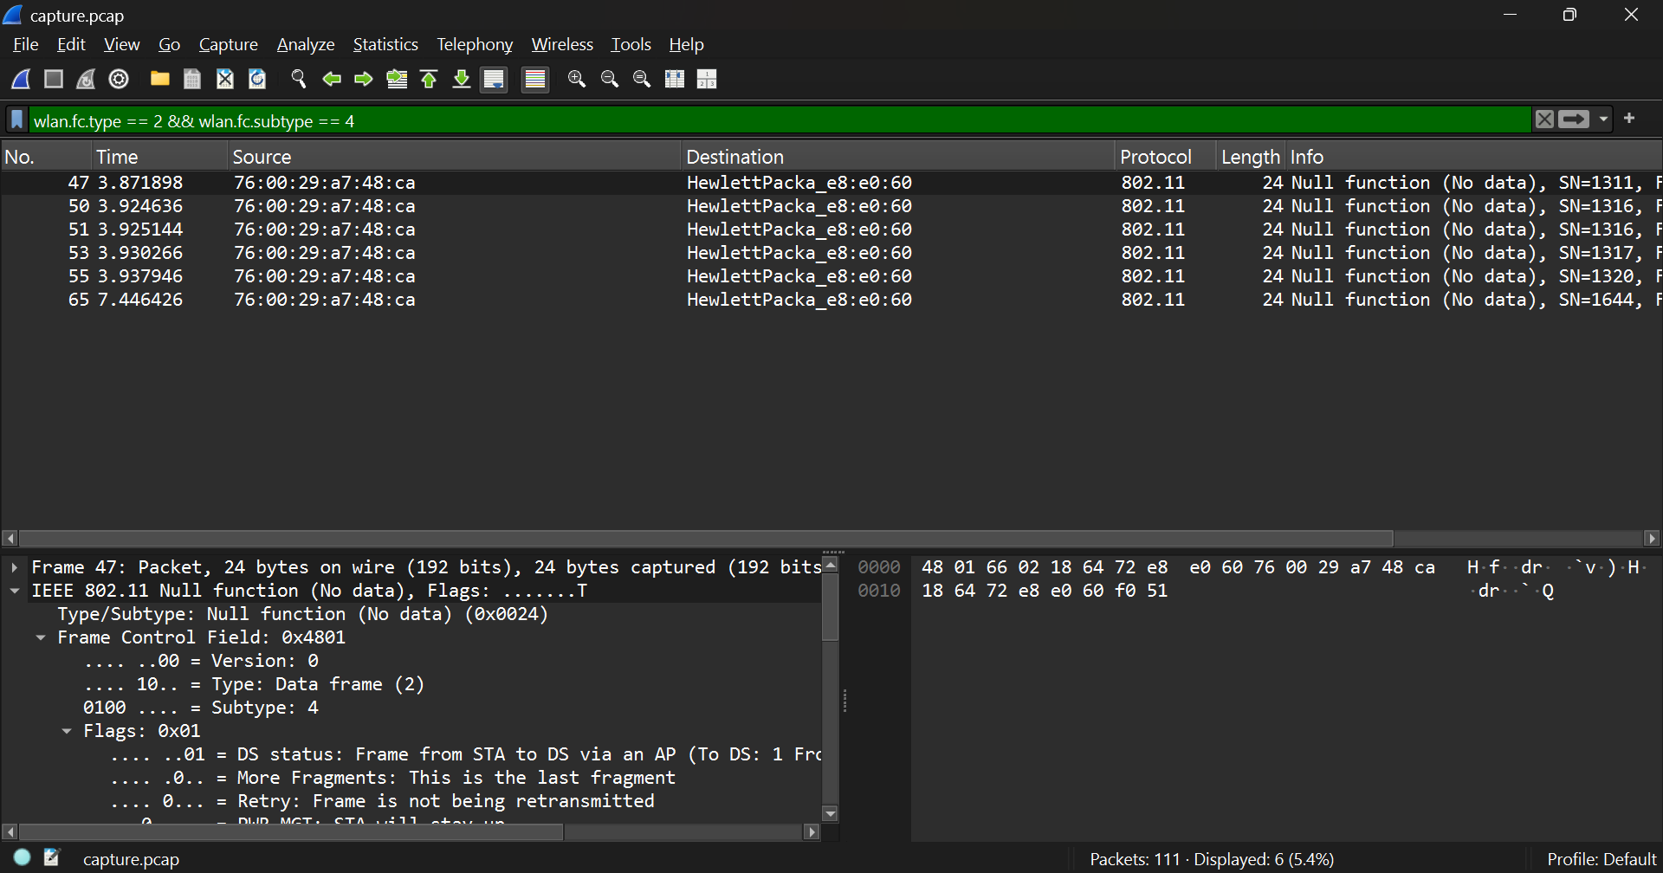
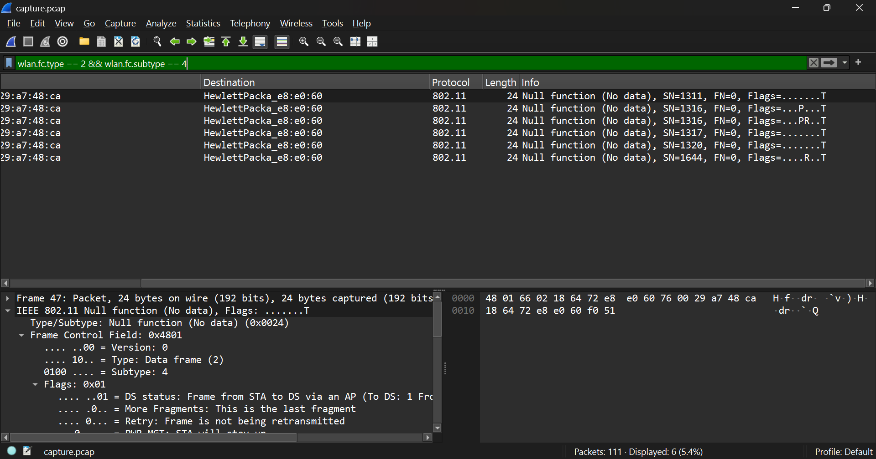
When the filter wlan.fc.type == 2 && wlan.fc.subtype == 4 is applied, the capture shows several Null Data (Null Function) frames. These frames are special data-type frames that carry no payload.
Purpose of Null Data frames:
- Null data frames are used by client stations (STAs) to communicate power management states to the Access Point (AP) without sending actual data.
- They serve as control signals to indicate when a device is entering or leaving a low-power (sleep) mode.
Power Management bit:
- The Power Management (PM) bit is located in the Frame Control field of the 802.11 header.
- PM = 1: The station is entering Power Save (sleep) mode.
  - The AP buffers incoming packets for that station until it wakes up.
- PM = 0: The station is active and ready to receive frames immediately.
How stations use this mechanism:
- A client sends a Null Data frame with PM = 1 to notify the AP it is going to sleep.
- The AP buffers all traffic destined for that client.
- When the client wakes up, it sends another Null Data frame with PM = 0, signaling it is awake and ready to receive the buffered packets.
In the capture:
Frames from source 76:00:29:a7:48:ca to destination HewlettPacka_e8:e0:60 show Null function (No data), indicating this power management signaling between a station and an AP.

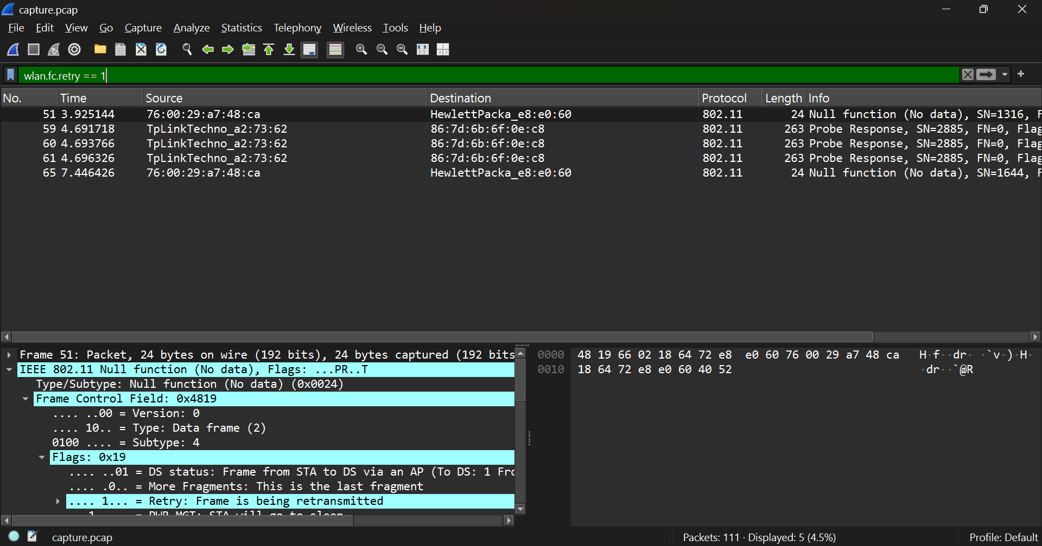
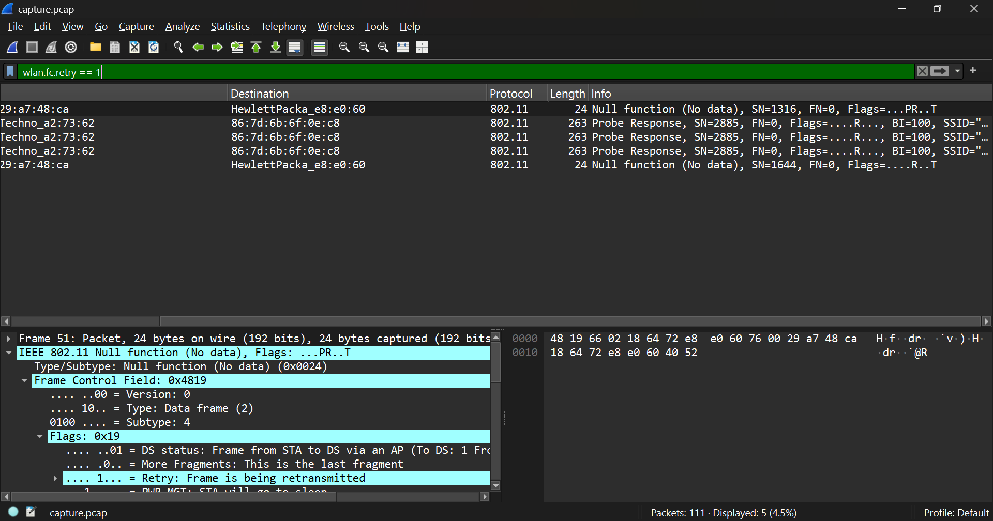
When the filter wlan.fc.retry == 1 is applied, the capture shows several retransmitted frames, such as Null Function (No data) frames and Probe Response frames with the retry flag set.
Reason for retransmissions in Wi-Fi:
Retransmissions occur when a sender (station or access point) does not receive an acknowledgment (ACK) for a transmitted frame within a specified time. To ensure reliable delivery, the sender retransmits the frame.
Common causes of retransmissions:
- Weak signal strength or low RSSI (distance from AP or physical obstacles).
- Radio interference from other Wi-Fi networks or electronic devices.
- Channel congestion due to multiple users sharing the same frequency.
- Collisions caused by overlapping transmissions in busy environments.
Interpretation of frequent retries:
- A high number of retransmissions indicates poor wireless conditions, such as noise, interference, or low signal quality.
- It can also point to overlapping channels or network congestion, leading to degraded throughput and latency.
In the capture:
Frames like those from source 76:00:29:a7:48:ca show the Retry bit set (Flags: ....PR..T), confirming retransmissions caused by missed ACKs or weak signal conditions between the station and AP.

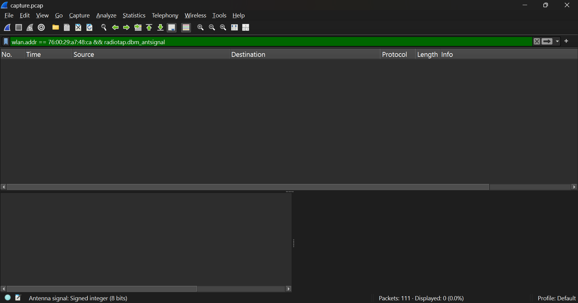

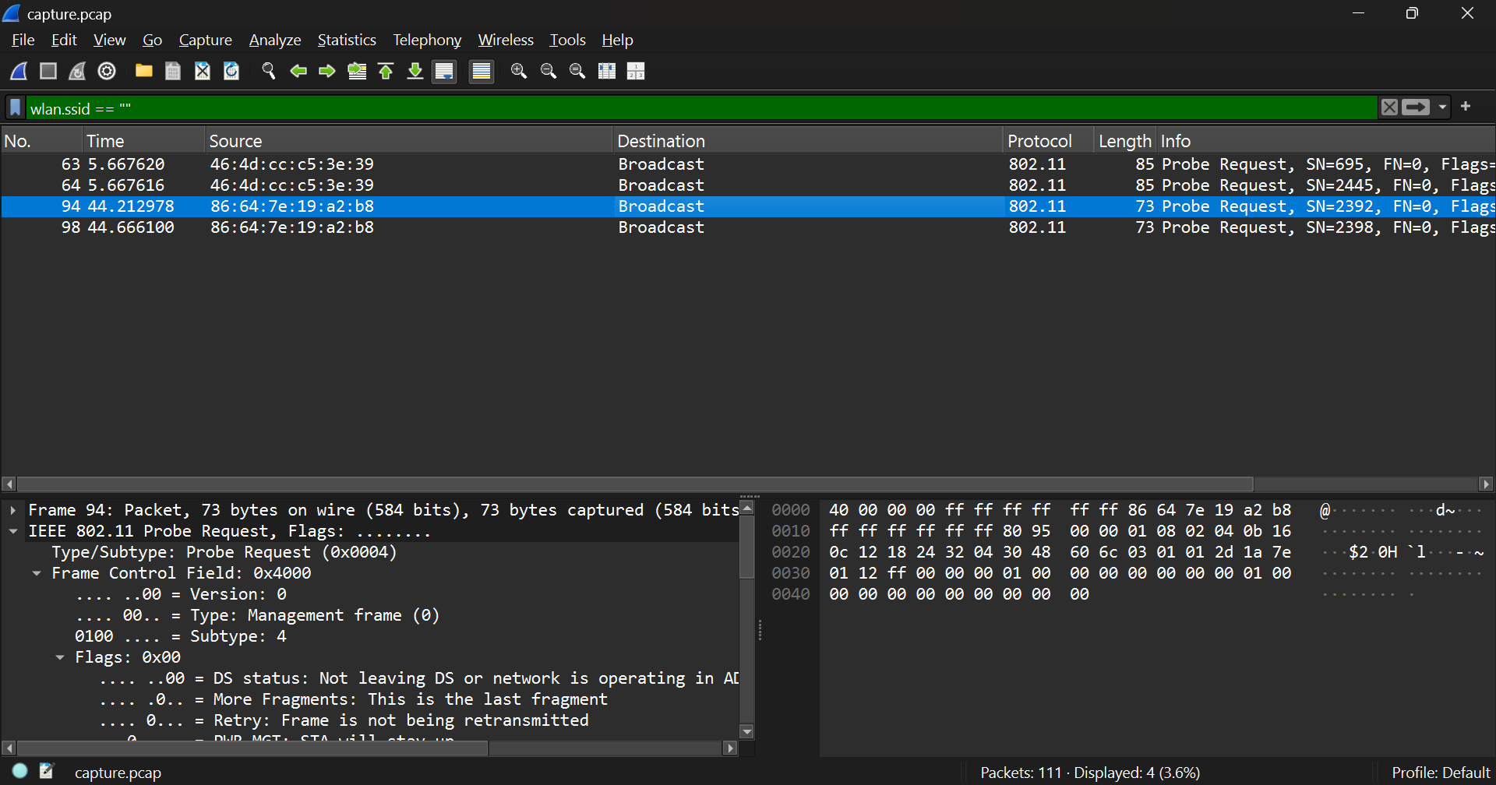
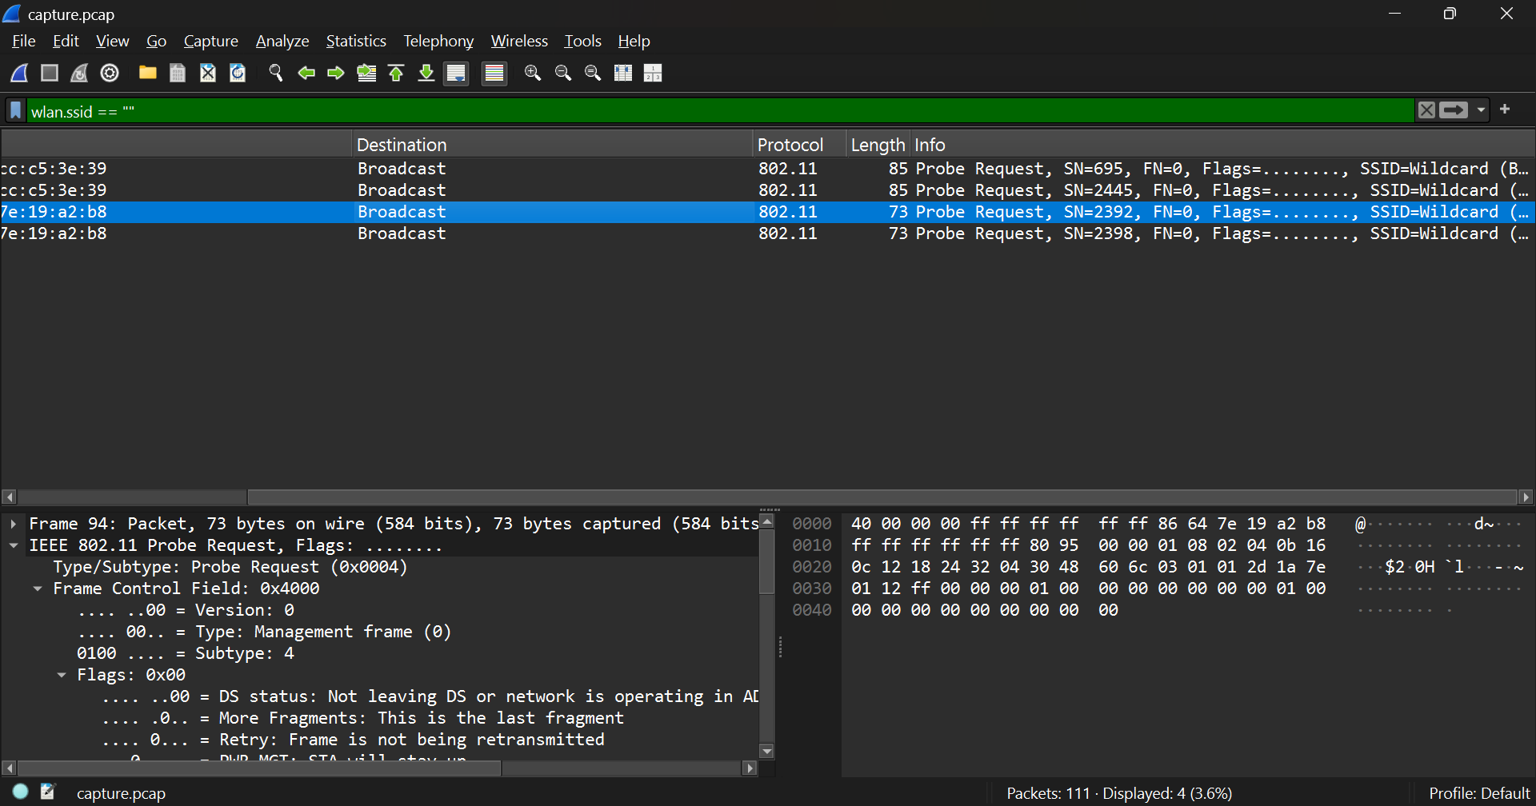
When the filter wlan.ssid == "" is applied, the capture shows Probe Request or Beacon frames where the SSID field is empty.
Meaning of empty SSID:
- An empty SSID (also called a hidden SSID) means the access point (AP) is not broadcasting its network name in beacon frames.
- Such networks are referred to as hidden networks because they conceal their SSID from casual scanning.
- Instead of advertising the SSID in beacon frames, the AP leaves the SSID field blank (""), making the network invisible in the default Wi-Fi list.
How clients can still discover or connect:
- Manual configuration:
  - A client device that already knows the SSID can still connect by sending a directed Probe Request with the specific SSID name instead of the wildcard value.
  - The AP responds with a Probe Response if the SSID matches, allowing the device to connect.
- Stored profiles:
  - Devices remember previously connected hidden SSIDs and periodically probe for them automatically.
In the capture:
Frames with SSID: Wildcard (Broadcast) and empty SSID (“”) indicate clients searching for any available or hidden networks. This mechanism allows connection even when the network name isn’t openly advertised.

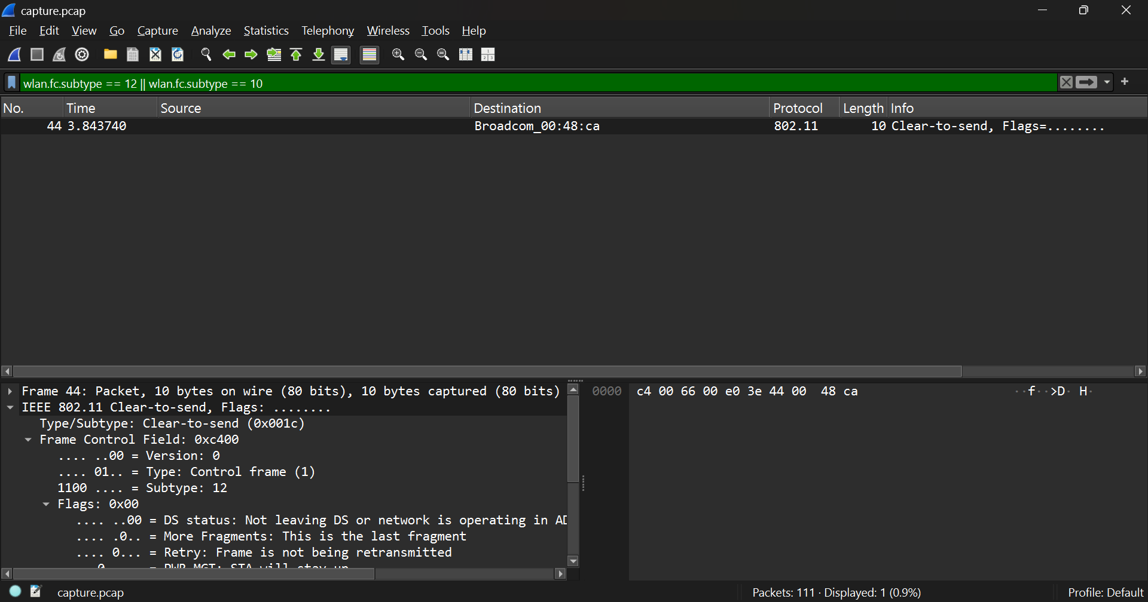
When the filter wlan.fc.subtype == 12 || wlan.fc.subtype == 10 is applied, the capture shows Control and Management frames, such as the Clear-to-Send (CTS) or Deauthentication/Disassociation frames depending on the traffic captured.
Specifically for Deauthentication (subtype 12) and Disassociation (subtype 10) frames in IEEE 802.11:
What triggers these frames:
- Deauthentication frames are sent when:
  - A client or AP wants to terminate authentication (logout).
  - The connection is closed intentionally (manual disconnect or roaming).
  - The AP enforces disconnection due to idle timeout, security mismatch, or policy violation.
  - During roaming, when the client moves to another AP.
- Disassociation frames are sent when:
  - The client or AP wishes to end the association but keep the authentication intact.
  - This typically happens before deauthentication or when switching between APs.
What happens after these frames are sent:
- Once a Disassociation frame is sent, the client is no longer associated with the AP and cannot send or receive data frames.
- Once a Deauthentication frame is sent, the client is completely disconnected and must restart the connection process (authentication → association → data transfer).
- The AP releases resources (buffers, AID) used by that client.
In the capture:
The displayed frame shows a Control-type CTS (Clear-to-Send) frame under the same filter, which is closely related to managing the transmission channel. However, when Deauthentication or Disassociation frames are present, they indicate session termination events between a station and an access point, marking the end of a connection in the 802.11 link layer.

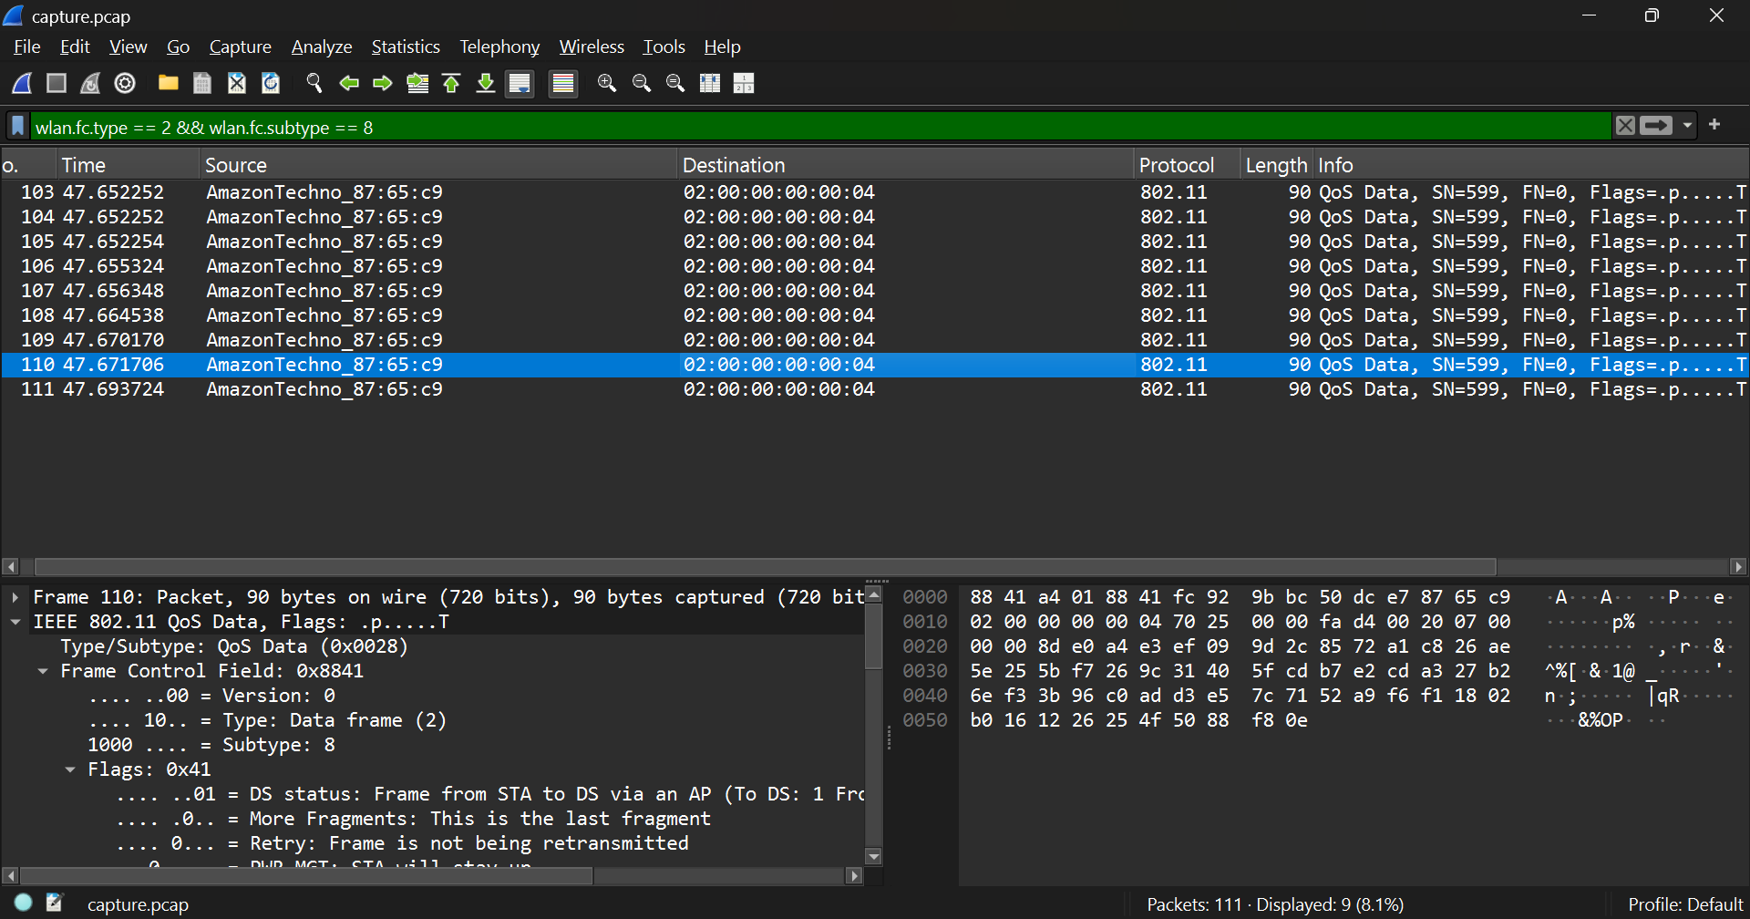
When the filter wlan.fc.type == 2 && wlan.fc.subtype == 8 is applied, the capture shows QoS (Quality of Service) Data frames, such as those transmitted from source AmazonTechno_87:65:c9 to destination 02:00:00:00:04.
Role of Quality of Service (QoS) in Wi-Fi Communication
QoS in IEEE 802.11 networks (defined in the 802.11e amendment) is designed to prioritize certain types of network traffic to ensure that time-sensitive data receives better treatment than normal data.
It enables efficient sharing of the wireless medium by assigning different priority levels to various traffic categories.
QoS frames contain a QoS Control field that defines the traffic category or Access Category (AC):
- AC_VO (Voice) – highest priority
- AC_VI (Video) – high priority
- AC_BE (Best Effort) – normal traffic (e.g., web browsing)
- AC_BK (Background) – lowest priority (e.g., file downloads)
How QoS Works
- Wi-Fi uses EDCA (Enhanced Distributed Channel Access), which gives each category different contention parameters (shorter wait time for higher priority).
- Frames belonging to higher priority traffic (like voice or video) get faster access to the medium, reducing delay and jitter.
- Lower priority frames wait longer, ensuring smooth transmission for critical real-time applications.
Traffic Types that Benefit from QoS Prioritization
- Voice over IP (VoIP) calls – need very low delay and jitter.
- Video conferencing or streaming – benefits from consistent throughput and minimal packet loss.
- Online gaming – improved responsiveness due to low latency.
Other traffic like web browsing or file transfers (best effort/background) can tolerate slight delays, so they receive lower priority.
In the Capture
The QoS Data frames from AmazonTechno_87:65:c9 indicate that the device is transmitting user data with QoS enabled, likely classifying packets into one of the above access categories to optimize wireless performance.

Common observations (2.4 GHz):
- Channels mapped to frequencies:
  - 2412 MHz → Channel 1
  - 2437 MHz → Channel 6
  - 2462 MHz → Channel 11
- Most small deployments use channels 1, 6, 11 to avoid overlap.
How overlapping channels or interference degrade performance:
- Overlapping channels (e.g., channel 3 overlapping 1 and 6) cause adjacent-channel interference: signals partially overlap in frequency and disrupt each other, increasing collisions and retransmits.
- Co-channel interference (many APs on same channel) increases contention — devices defer more often, throughput per device drops.
- Non-Wi-Fi interference (microwaves, Bluetooth, cordless phones) raises noise floor, reducing SNR and effective throughput.
- Result: increased latency, more retries, rate fallback, reduced throughput and reliability — worst impact is on latency-sensitive traffic (VoIP, gaming).

